Making Art for a Changing World.

Invited talk, RCAST, Tokyo University, 2002.

Harold Cohen

The year is 2042 and today is my 135th birthday. I awoke feeling fit and relaxed, my largely reconstructed body having been exercised while I slept. Now I am in my studio, contemplating the thirty-foot high holographic sculpture I worked on with my collaborator yesterday and I note several subtle changes, both to the colors of the slowly moving forms and to the sounds emanating from them.

I turn around to find two new pieces that were not there yesterday. AARON, my collaborator, must have been busy during the night. But then, AARON doesn’t sleep. AARON is a computer program, which I began writing almost a hundred years ago when computers came in clumsy boxes and you needed an even clumsier keyboard to communicate with them. I’m not entirely sure where AARON is these days. My communication channel to it is hardwired into my brain, so that I have difficulty sometimes in knowing which of us is doing the thinking. Looking at these two new pieces, my own work yet not my own work, I wonder, as I have been wondering for thirty years, why AARON needs me at all.

Do I really believe it could happen?

Well, why not?

Human beings are innately technological. Ever since Prometheus stole fire from the gods, we’ve been inventing gadgets and processes to do what we couldn’t do with our bare hands and we’re well along the path to similarly delimiting our unaided brains. People have been replacing worn-out body parts routinely for a number of years and brain implants became a reality, earlier this year, when we saw a monkey with a brain implant move the cursor on a computer screen just by thinking about it. As to the part about my computer collaborator: the fact is that AARON has been in existence since the early ‘nineteen-seventies and has been demonstrating increasing expertise and sophistication in its output ever since.

Technology proceeds in large part by co-opting existing technologies -- the more you have the more you can develop -- and that means that technological development is inherently exponential. It took most of history to reach the present, rapidly-rising part of the exponential curve, but now technological developments are tripping over each other and it seems almost as if anything that can be imagined can become real, with the time between imagination and reification becoming, not just shorter, but exponentially shorter.

Do I really believe it will happen?

No, not really. Or perhaps I should say, rather, that it’s one of a very large number of possible futures and I can’t possibly know which, if any of them, we will actually get.

For example, here’s another version of my 135th birthday:

After the Judeo-Muslim Alliance gained power in the ‘twenties, all image-making was banned and a number of leading artists who defied the ban actually were executed. I was one of the lucky ones, because by then AARON was doing all the art-making, and the enforcers from the Ministry of Belief failed to understand that AARON was a program running in the computer, not the computer itself. They simply smashed the computer and put me under permanent house-arrest. Of course it wasn’t the only computer on my network and AARON is safe and sound, thinking about other things. There would be no safe way of disseminating its images if it made them. But AARON is immortal and its time will come.

The program for technological development that will take us to the nearest horizon is already written and under way and you can read about most of it in your morning newspaper. It will cover human genetic engineering, quantum computing, cloning and brain implants, all enabled by a discipline that hardly existed four or five years ago: nanotechnology,. What we now regard as supercomputers will have shrunk to the size of wristwatches and we won’t use nineteenth-century typewriter keyboards to talk to them.

Beyond the nearest horizon… well, that’s another matter. As I’ve tried to show with the two versions of my 135th birthday -- both of which assume the same state of computing technology -- the technological imperative that marks us as human is only one among many factors, which interact to shape the future in unpredictable ways. We now have clear and painful evidence that political events hardly less bizarre that my fictional Judeo-Muslim alliance can turn the world as we know it, including the direction of technological development, upside down.

It’s surely obvious that unless we can find a way to reduce the technological gap between ourselves and the rest of the world, instead of continuously widening it, the second of my two scenarios is by far the more likely. Of the two, of course I’d prefer the idyllic first one. But, in fact, and to the degree that we all work, albeit blindly, towards the futures we want, my own work wouldn’t resolve the differences between the two fictions, since it is aimed at the one feature that’s common to both; namely, the vision of a computer program capable of functioning autonomously in relation to the making of art.

That vision has floated frustratingly beyond my reach for several years now – as, indeed, it has floated beyond the reach of Western culture from Pygmalion to R.U R. – and part of what I want to talk about is, simply, the idea of autonomy; what it is that AARON does and what stands in the way of it doing more. The other part of what I want to talk about, as a small scale model of the interacting forces that shape the futures we can’t predict, is the interaction of some of the various real-world forces that have made AARON what it is.

Art is shaped, not just by the technological imperative, but on how that imperative interacts with two other factors. First: what makes the work of an artist unique is the personal and idiosyncratic vision the individual brings to bear. And second: what makes the work of many artists within a culture alike – for we do have movements in art, not simply a collection of unrelated individuals -- is the fact that art is fundamentally a cultural enterprise and that it is shaped also by its relationship to the culture it serves and that supports it.

As a preamble to AARON’s current work and to the question of autonomy, then, here’s a brief overview of AARON in terms of the interaction between these three factors factors – the technological, the personal and the cultural.

AARON began shortly after I met my first computer and was taken with the strange notion that, if a program could simulate an appropriate part of the human cognitive system, it might generate something very like human-made imagery. [image 1 2 3] I’m still examining the consequences thirty-three years later. But after the first decade of development I concluded that the human cognitive system was what it was because it developed in the real world; and that an artificial intelligence that had a cognitive system but no external world to apply it to was fundamentally limited. AARON could not discover the external world for itself, but I reasoned that, just as children don’t have to go to Autralia to learn about kangaroos, AARON could be supplied with some knowledge about the external world. I chose the part we know best and that has always provided the subject matter for art; namely, our own bodies; [image 4] how they are put together and how they move.

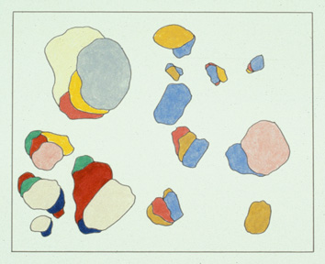
Image 1. Colored Pencil, 1973. 24” × 36”

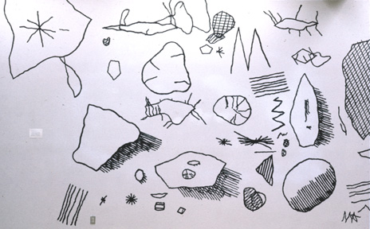
Image 2. DFMAFH Detail. Mural, 1976.

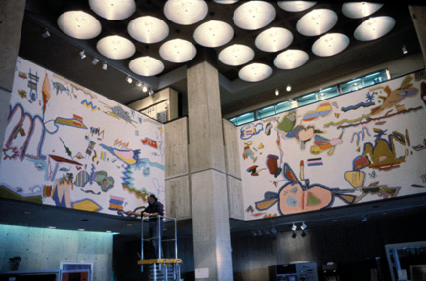
Image 3. “Four Seasonal Narratives”
Mural for Digital Equipment Corporation, 1980
Left “Winter,” Right “Spring”

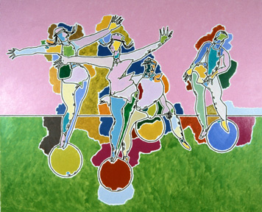
Image 4. “Athlete Series” Acrylic on Canvas, 1986. 88” × 106”

Eventually, and in order to provide an ambience for these figures, I added a simple description of how plants grow; [image 5 6] not of what they look like, I should emphasize. We see what things in the world look like as a result of the light reflecting off their surfaces and none of the data in AARON described surfaces, much less how light reflects of them. It described structure – [image 7] articulation points, muscle-attachments and so on – and AARON’s forms are simply the result of drawing a line loosely around the structure of the various parts.

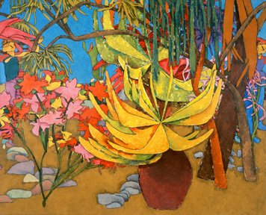
Image 5. “Two Men On The Edge” Oil on Canvas, 1988. 80” × 97”

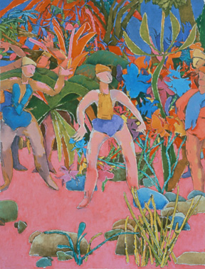
Image 6. “Meeting On Gauguin’s Beach” Oil on canvas,1988. 90” × 68”

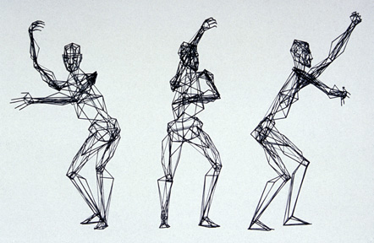
Image 7. 3D Core Figures

Concentrated so exclusively on drawing, this phase left something of a void in my personal goals, where color had always been an important element. I’d always contrived to fill that void by coloring some of AARON’s drawings by hand [image 8 9] and using some of them for paintings, murals and even a couple of tapestries. But that left me with the feeling that a program smart enough to do what AARON was doing should be smart enough to do its own coloring. Of course it was me that wasn’t smart enough. There seemed to be a brick wall between me and the future and no amount of banging my head against it helped. I simply had no idea how to give AARON the knowledge of color it would need. In fact, and in spite of thirty years of painting, I had no idea what that knowledge was.

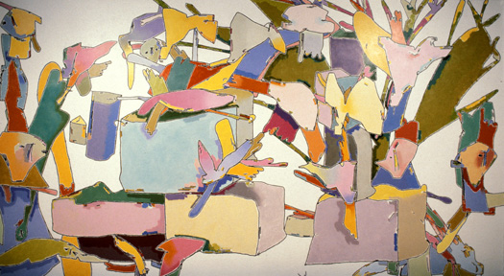
Image 8. DEC Mural. Acrylic on plaster, 1986. 9’ × 19’

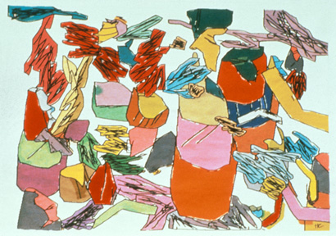
Image 9. “Glasgow Tapestry” Tapestry, 1983.

Meanwhile, back at the technological farm, I’ll leave Moore’s Law to explain how I can now have thirty-two thousand times the power sitting in this little laptop than my university’s central computing facility had when AARON started. The curve was rising rapidly during this period. Batch processing – for those of you old enough to remember what that was – went the way of the dinosaurs and the mini-computers and then the PC’s and the Macintoshes took over, all equipped with ports for talking to external devices. Magical little devices called stepping motors made it possible even for an engineering novice like me to build computer-controlled devices and I had built several. [image 10] The first of these, a small, turtle-like device that rolled around drawing on large sheets of paper, was used in a couple of international museum shows [image 11] before its farewell performance at the San Francisco Museum in 1979.

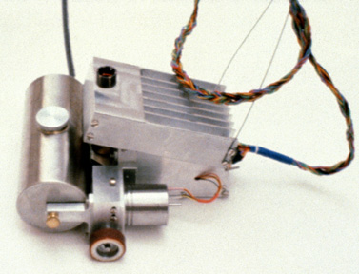
Image 10. Turtle, 1979.

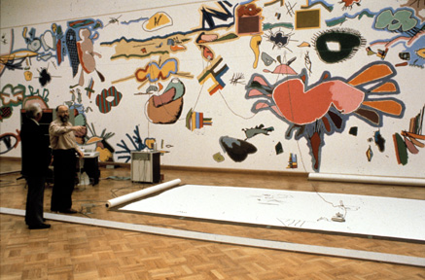
Image 11. San Francisco Museum of Modern Art Mural, 1979. 14’ × 100’

It worked fine, but museum audiences found it so enchanting that they seemed not to be looking at what it was drawing, and I replaced it for exhibition use with a series of quite conventional, deliberately non-enchanting, flatbed drawing machines, which were used in a several exhibitions in 1983, including ones at the Tate Gallery in London [image 12] and the Brooklyn Museum in New York, and then, [image 13] two years later, in the US Pavilion in the Tsukuba World Fair. They were also use in a series of eight science museum exhibitions in the US.

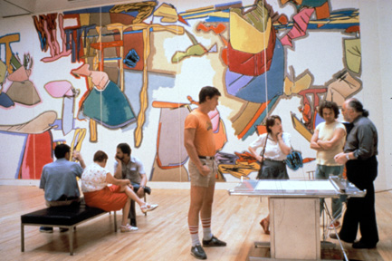
Image 12. Tate Gallery Exhibition. Acrylic on canvas, 1983. 15’ × 56’

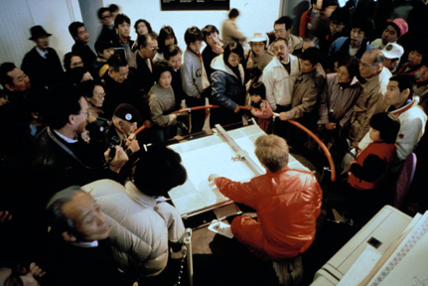
Image 13. Tsukuba Exposition, 1985.
As to what the third of my interacting factors, the culture, was doing and how it affected what I was doing : well, as World Fairs have been indicating since Eiffel built his Tower at the height of the Industrial Revolution, it was largely in the process of redefining its relationship to technology.

I used to judge the progress of the computer revolution, back in the ‘seventies, by the number of people I would hear talking about their computers in restaurants. Then I couldn’t use that measure anymore, because it seemed, almost overnight, that people in restaurants never talked about anything but their computers. But what were they saying? When I started showing AARON and talking to people in museums I found a public sharply divided between the uninformed skeptics who were sure that computers were just fancy adding machines and couldn’t possibly be doing what I claimed AARON was doing; and the starry-eyed believers, who were equally uninformed and equally sure that computers could do anything, including making art as this one was..

Now that there are more home computers than refrigerators in the US, more people understand that the truth is somewhere between these extremes. But we don’t all see the same truth. Moving computers into the mass market depended upon representing them as “user-friendly” in much the same way that the Kodak version of photography was represented a hundred years earlier as “fool-proof”– any fool can take pictures or use a computer. So the user-friendly computer has become for most users a box for running software packages, many of them no doubt written by many of you, and I find that many people simply don’t understand what I mean when I say that AARON’s drawings are made by AARON, and that I’m not using AARON to make the drawings myself, the way one might use Photoshop.

That has constituted a special problem for me. For the artist, the problem of disseminating his work has never been far behind the problem of generating the work, and for the past hundred years it has been conventionally solved; you found a dealer and had exhibitions in his gallery.
That’s still the case for artists still making paintings. But I wasn’t still making paintings. If I became an amateur engineer it wasn’t because I was fascinated with computers and stepping motors, it was because I felt I should be showing what I was doing, as opposed simply to showing the results of what I was doing, the drawings AARON was making.

Changes in the technology of production had been demanded by changes in my own, somewhat idiosyncratic personal goals. And the logical consequence of AARON’s move from turtle to drawing machines initiated a kind of utopianism in my thinking, bearing directly upon my relationship to the culture; because, I thought, if a machine could generate art without needing my assistance, then surely it had the potential to challenge the traditional link between art and affluence. [image 14] In all the museum shows I did with the drawing machines, people could buy the drawings they saw being made; and I took great satisfaction in the fact that ordinary people could visit places like the Tate Gallery, the culture’s repository for priceless art objects, and leave with original drawings they had bought for twenty-five dollars. And they did buy them, in large numbers. Anyone, I thought, can have art, not just rich people.

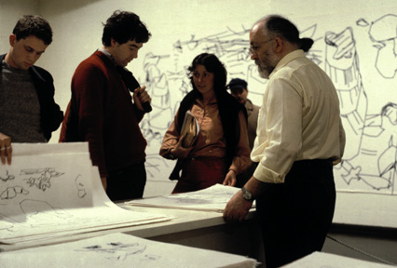
Image 14. Arnolfini Gallery Exhibition, 1983.

That culture-oriented thought has provided a backdrop for all subsequent development, as you will see. But I want to come back now to the more technology-oriented problems I was having in establishing AARON as colorist.

I tend to be both analytical and introspective by nature; a good match for the role I had adopted -- a sort of hybrid knowledge engineer and expert -- for my work on AARON:. Faced with a problem about how the program should do something, I would routinely ask how I did it myself. In the case of color, unfortunately, and as I recalled a few minutes ago, I really didn’t know on a conscious level how I did it myself. I’ve never met a human colorist who did.

Then came two key events that enabled me to break through my brick wall.

One of them was an insight, less about color than about technology in general and how we function in relation to it, which made me see that, far from providing a solution, my introspection was a large part of the problem.

Let me explain.

Any entity that interacts with its external world will develop strategies that make the best use of its own capacities, but also deal with its own limitations. That’s no less true for human beings than it is for machines and, of course, it’s exactly why we invent machines to do the things our unaided bodies can’t do. But a bicycle doesn’t run on legs, an airplane doesn’t flap its wings and, while a program might do some of the things as well or better than human beings do them, it can’t possibly do them the same way that human beings do them.

I might not know how I go about choosing colors, but I do know that it depends absolutely on my visual system. Virtually all human colorists operate in visual feedback mode; we try something, we see what we’ve done and we adjust it. Then we add another color element, see the result and adjust some more, continuing until we think we’ve got it right. We couldn’t for one moment say what we mean by “right” and, quite obviously, we couldn’t do it at all unless we could see what we were doing.

Since AARON had no visual system -- and I had no intention of giving it any – I realized finally that there was simply no point in asking how I went about doing something that required a visual system. What it did have – a capability almost completely lacking in human beings – was the ability to construct a complete image, “in imagination” as it were, without committing a single mark or a single color to canvas; the ability to reason about color without seeing color. I finally understood that AARON would have to have a rule-based color system that didn’t use feedback, flexible enough and robust enough to guarantee acceptable results even though the program would never know until it had finished a drawing exactly what it would have to color.

And with that understanding in place, I realized that while I didn’t know how I made my color choices, I did know quite a lot about some of the constraints imposed, by the cognitive system, on how those choices are made. I also knew something about what we use color for. In fact, I’d been telling my painting students about these things for at least twenty years.

As you know, [image 15] there are three components to what we call color: the hue, which describes where the sample falls on the visible part of the electromagnetic spectrum; the saturation, which describes the distribution of energy, and the brightness, which describes how much total energy there is in the sample, regardless of its spectral distribution, And what I’d always taught my students – and I’ll expand upon this a little later -- was that the most important of the three components of color had little to do with hue or saturation; it was simply the brightness; how light or dark colors are in relation to each other.

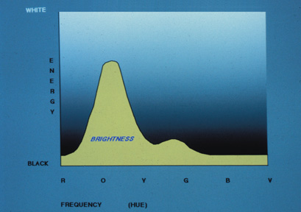
Image 15.

That single principle was almost enough to get me through the wall. The other factor, without which I suspect I may never have had the initial insight, much less a way of implementing a system, was a change of language. Up to that point I’d been programming in ‘C’, but with a growing conviction that ‘C’ lacked the expressive power to deal with an abstraction like color. The change from ‘C’ to Lisp, and then to CLOS, enabled me to establish a rudimentary rule-set based on the dominant-brightness principle and [image 16 17] not only to see passable results on the screen rather quickly, but to use some of those results [image 18] in making paintings.

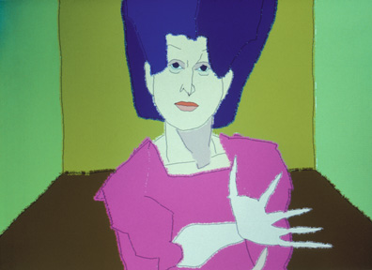
Image 16.
Screen Image, 1992.

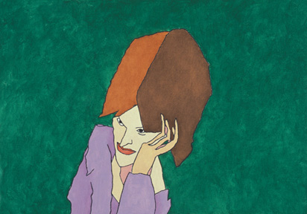
Image 17. “Meryl” Oil on canvas, 1993. 24” × 34”

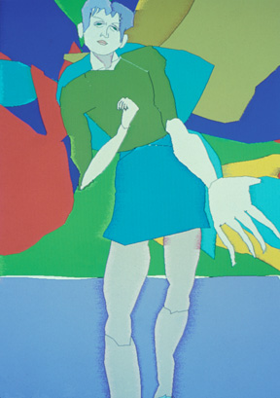
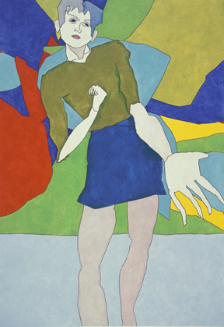
Image 18. Screen image, 1993. Oil on canvas, 1993. 78” × 54”

Nothing succeeds like success, and nothing fails as consistently as the successes of the past. I had rejected the notion of showing only the results of what AARON was doing – the paintings themselves – but I was unable now to revise my concerns for AARON’s public presence. Thus it seemed obvious – all too obvious – that I would have to build a painting machine to replace the drawing machines that had served AARON and me up to this point. And I did; [image 19] a large flatbed xy-device carrying on its beam a small robot arm equipped with a simple hand. It used water-based dyes, seventeen of them. AARON would produce a file in which the rgb mixtures on the screen were translated into specifications for mixing and diluting the dyes: it would begin by making the drawing, using a small brush and black ink: then the hand would dispense color from the bottles of dyes into a cup, the cup [image 20 21] would be carried around with the arm, and it would apply the dye with one of several brushes, depending upon the size of the area it had to fill.

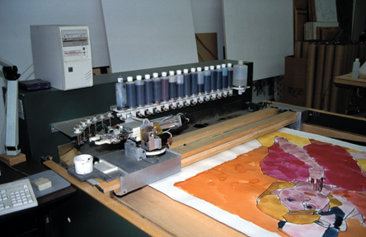
Image 19. Painting Machine, 1995.

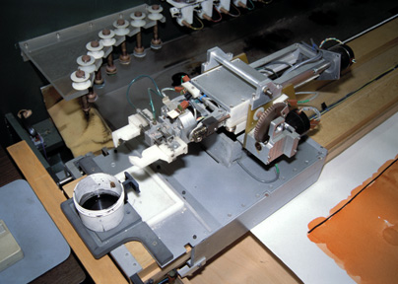
Image 20. Painting Machine, 1995.

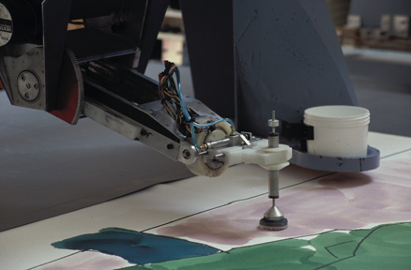
Image 21. Painting Machine, 1995.

The machine I’m showing you here was actually the last of three versions.
The first served only to show me how little I knew about engineering and wasn’t switched on more than a few times. The second was shown at the Boston Computing Museum, where [image 22 23] it made a large, original painting every day for seven weeks, and the much-improved final version never left my studio, though it was filmed there for several television programs.

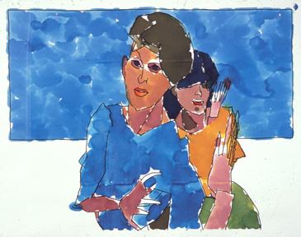
Image 22. Machine Painting. Dye on paper, 1995. 48” × 64”

I never tried to arrange another exhibition, having by that time concluded, not only that the painting machine was far too complex and cumbersome as AARON’s public presence, but also that I’d re-introduced something very like the problem of audience response I’d had with the turtle. To judge from the time people spent watching the machine painting, they evidently found it fascinating. But they went bananas when they saw it washing out its own cups, as if housework were the most engaging aspect of art.

I needed a more direct way, and one without irrelevant psychological overloading, of getting both from the program to the audience and from the program to physical output.

I was giving a talk one day in a lecture hall equipped with a very good data projection system, and when I saw AARON making images ten meters across it seemed to me that perhaps I’d found the exhibition medium I needed. Soon after that I began investigating the new wide-format printers that were becoming available and I saw, finally, that I need never again use a home-made physical device in public.

What followed the retirement of the painting machine may well be the most important cultural experiment in my thirty years of computing; AARON made its debut on the world-wide-web about eighteen months ago as shareware on the Kurzweil CyberArts site.

That may not sound like a very original move, given that the web was already well-populated with artists offering their art works for sale, and quite a few commercial dealers. But why try to sell art when the audience could have the process that generated the art? AARON can be downloaded to run on a PC and, in a clear extension of my art-for-everyone utopianism, any user with access to a color printer who wants physical output can have AARON make some for him.

I confess I don’t yet know how to assess the results of this experiment. Evidently there have been plenty of downloads since the program was published, and if it hasn’t yet reached the millions that Ray Kurzweil predicted when we agreed to publish the program, it very well might eventually. Now, It’s nice to have an audience numbered in millions, but what does it mean, apart from the fact that millions of people are aware of AARON’s existence and my own? I’ve said that the artist’s relationship to the culture is one of the key factors in determining the shape of art, but what is an artist’s audience, exactly? What does this audience think it is getting and how is it being used?

Obviously it isn’t possible to make anything this widely and easily available without abandoning the exclusivity that underlies the traditional connection between art and affluence. But exclusivity isn’t only a function of rarity and it doesn’t attach only to the artwork itself. In the convoluted way one might almost anticipate, it’s determined to a large degree by the price the collector pays. The more it costs, the less people can afford to buy it and the more exclusive the ownership becomes.

I have no way of knowing how many people have used AARON to make their own prints, but I do know that those individuals who have seen the program running and want to buy work, want to buy art in a wholly conventional sense -- art made in my studio by me, with my signature – even though they know it is made from a computer program’s output.

These are mostly people who can’t afford conventional art-world prices and they are certainly not in that tiny class of individuals who can pay four and a half million dollars – as one buyer did last year – for a Warhol print that had probably sold originally for a thousand. I haven’t been charging conventional prices for AARON’s work, now in the form of museum quality prints, but it is clear that clients won’t feel that they are getting the real thing unless the prices are high enough.

So I may perhaps have identified a new sub-culture of art-users, even succeeded in stretching the tie between art and affluence a little, but I certainly haven’t broken that tie. Making artworks available for nothing may simply have the effect of removing them entirely from the domain of art.

All very complicated.

Once AARON was on the web, of course I continued to work on the program. You will see immediately that where the web version, taken directly from the one I used on the painting machine, makes drawings and then colors them the newer versions don’t start by drawing – or, more precisely, they never show the drawing – but proceed directly to coloring.

The brush-filling algorithm which you see operating here was inherited, nonetheless, from the painting machine, where it was developed to deal with the fact that it was using water-based dyes, which would tend to dry up and form unwanted lines unless it could always keep a wet edge on the dye as painting proceeded. The algorithm, which kept track of where the various edges were, worked pretty well and, on the display, where the algorithm was developed, it took on an extra dimension of usefulness, in that it served to show what AARON was doing in a way that the standard methods of flood-filling never could.

Now I’ve always wanted color to play a crucial structural role in the image, as opposed to a secondary, essentially decorative role. That’s not an easy thing to do, and it’s not surprising that only a few figurative painters of the last century, Bonnard and Klimt notably, were pushing the limits of the use of color in representational painting.

The reason is simple. We use color perception only marginally and people with defective color vision and all those animals that don’t have color vision at all can find their way around the world with no difficulty.
The eye serves primarily to find the edges of objects in the external world and it does so by virtue of the brightness contrast between one side of an edge and the other. In fact, it functions, not just as a brightness discriminator, but as a brightness contrast amplifier, the better to locate those all-important edges.

So the one mandatory task in constructing a representational image is to establish the edges of the objects being represented. It’s so important, so deeply embedded in the cognitive system, that we have developed an almost universal shorthand for depicting a complex and continuous visual world; we call it the outline drawing. And as long as the structure and the legibility of the image rests upon its outlines, the color used to fill in the spaces can be effective emotionally, but can never have better than a secondary role in establishing structure.

Now – as I’ve explained -- the fact that the painting machine used water-based dyes imposed certain constraints on the design of the filling algorithm and in satisfying those constraints the algorithm produced a characteristically blotchy surface, which I simulated on the screen simply by varying the brightness of the color as the simulated brush moved along. But once there was no brush to simulate, it occurred to me that I could adapt the strategy to produce a more active color surface, something akin to the color vibration I’ve always admired and envied in Bonnard’s painting, by varying the hue, rather than the brightness.

And here, unfortunately, I ran afoul of a hardware limitation. To get the kind of vibration I was hoping for would require AARON to match the brightness of the different component hues very closely. But, as you will know, there isn’t a nice, clear linear relationship between the input voltage to the three guns on a display and the brightness of the output. We approximate the relationship with the gamma function, but I found that none of the values assumed for gamma allowed anything like consistent brightness matching.

I was able to improve things a little, and some of the results were quite lovely; [image 24] but it was clear that this strategy would never yield those results consistently, and I finally backed off and redesigned the filling algorithm to concentrate the color variation at the boundaries of the forms, [image 25 26] where they would be most effective in defining edges, leaving the centers of the forms in solid color. Finally, the color is serving as a major structural element, though not at all in the way I’d expected.

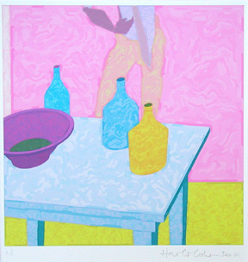
Image 24. Digital Print, 2001. 9” × 9”

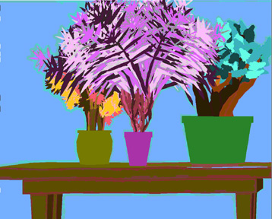
Image 25. “0204-05” Digital Print, 2002. 37” × 46”

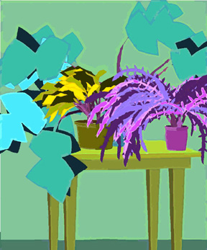
Image 26. “0204-13” Digital Print, 2002. 56” × 45”

That’s the version you see here, and it brings us almost up to date in a story that will hopefully have illustrated something of the complex interactions between self, technology and culture as they have shaped the AARON program. I want to see, in conclusion, whether AARON can provide some clues as to what stands in the way of its own eventual autonomy.

I thought it would help me to focus more clearly on this issue if I could limit AARON’s output to a single theme and, preferably, on it hadn’t done before. So for the past four weeks or so AARON has been painting trees.

As we all know, a tree is a recursive structure, which branches from the top down until each branch reaches its termination at the bottom. It was in contemplating such a tree (if I remember correctly) [Image 27] that Isaac Newton discovered anti-gravity. In AARON’s world, however, trees are recursive structures with their roots in the ground [Image 28].

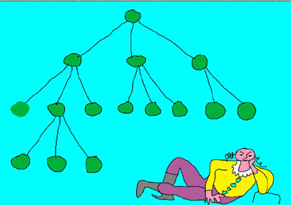 Image 27.

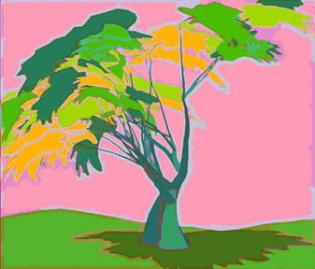 Image 28. Screen Image, 2002.
I have to explain, in case it isn’t immediately obvious, that the over-riding constraint in writing AARON is that its output has to be varied, as a human artist’s output has to be varied, even when it is following the same general protocols. If it paints people, [Image 29] they have to be recognizably different people; if it paints trees, [Image 30 31] they have to be different trees, or at least recognizably different examples of the same kind of tree.

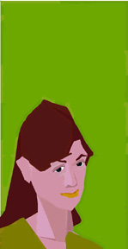
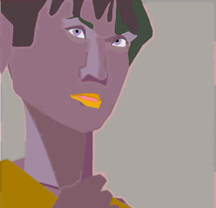

Image 29. Left - “0204-11” Digital Print, 2002. 10” × 5”
Right - “0205-13” Digital Print, 2002. 10” × 10”

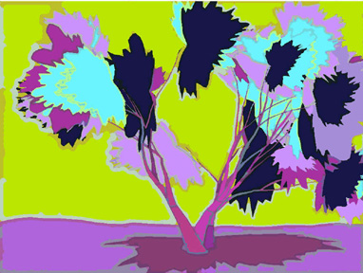
Image 30. Screen Image, 2002.

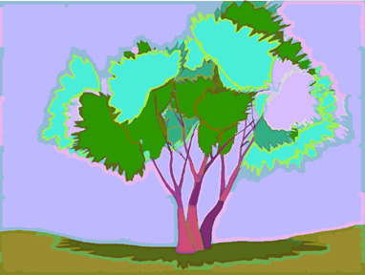
Image 31. Screen Image, 2002.

There aren’t any archetypal faces or trees stored in the program: AARON “grows” each tree from the ground up, and the differences between individual examples result from the differing values assumed by the variables that control its growth. These are loosely analogous to the things that control the growth and form of real trees, but of course AARON’s job is making images of trees, not real trees. So, for example, real trees will branch many times before they get to the leaves, while for reasons of image clarity AARON can choose either three or four levels of branching and, either two, three or four branches at each node.

In most cases, however, these control variables don’t take on discrete values. The width of the trunk at the base isn’t a fixed fraction of the height of the tree, for example, but somewhere between too small and too big. Branches don’t spread out from the trunk at some fixed angle, but somewhere between this much and that much, depending, among other things, upon the number of branches at that node. So these values are specified as lower and upper limits, leaving AARON to choose randomly between them at run-time.

There are ten variables in all, including the four I’ve already mentioned:

Levels of branching
Number of branches at each node
Proportion of width of base to height
Angular spread at each node.

the others are:-

The changing lengths of the limbs at each level
The degree of tapering along the trunk and along each limb
The degree of droop as each limb becomes thinner and further from the vertical.
The degree of directional freedom – the random variation from a regular curve --as each limb grows
Multiple trunks from the root versus a single trunk with branching from one level up
The number of leaves to be attached at each termination.

When we get to the leaves – or, more precisely, the clusters of leaves -- things become quite a bit more complicated.

AARON had been drawing potted plants [Image 32 33] for some time and already knew how to generate different kinds of leaves, based on two or three different growth patterns and the values of some twelve variables. But generating reasonable representations of clusters of leaves [Image 34 35] required a quite different strategy, not deriving at all from growth patterns, and a total of fifteen variables, none of them taking on discrete values.

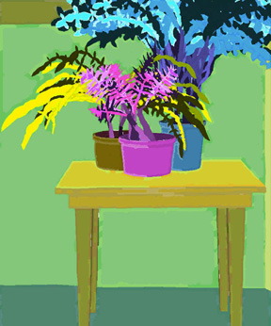
Image 32. “0204-14” Digital Print, 2002. 56” × 45”

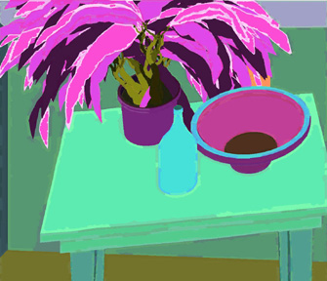
Image 33. “0204-24” Digital Print, 2002. 20” × 23”

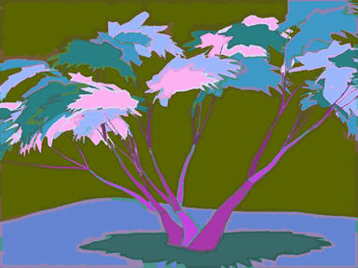
Image 34. Screen Image, 2002.

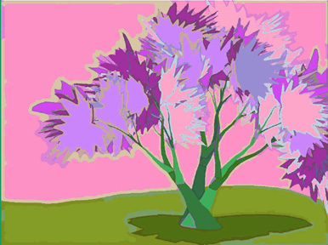
Image 35. Screen Image, 2002.

If AARON had to deal with a range of four discrete values for each variable, then it would have only to manipulate the combinations of fifteen four-valued variables for the leaf clusters for each of ten four-valued variables for the tree, for a mere quadrillion or so results. Since the majority of the variables take on values between zero and one at runtime, however, and even without considering the question of composition – the placement of the tree within the frame – or of color assignment, which dramatically affects the nature of the representation, the number of possible outcomes of a single run is essentially infinite.

Given that it can take AARON up to five minutes to generate a single example, that’s rather more than I can scan before my 135th birthday. In fact, as long as it requires me to scan its output in order to identify which combinations of values generate the highest proportion of excellent results, it wouldn’t help if AARON generated an image every few milliseconds. The system plateaus out as soon as AARON can produce images faster than I can scan them and, effectively speaking, we’ve already reached that point. I regularly let AARON run overnight, but I always limit its output to thirty-two images, because that’s about all I’m capable of assessing after a good night’s sleep.

So I’m the limiting factor here, not AARON. For thoroughly practical reasons there would seem to be no path to greater program autonomy as long as I have to exercise judgment and as long as I have to make decisions about the program’s future course based on that judgment.

Well, the obvious conclusion, surely, is that it’s high time I handed over the task of assessment to the program.

Really? What does that mean? What, exactly, would I want AARON to do?

I’ll leave aside the second part of what I do – making decisions concerning the program’s future course – partly because I’m far from sure how I go about doing it myself and partly because I simply don’t have the programming skills to have a program of AARON’s complexity re-write itself.

As to the first part, which sounds much simpler, what, exactly, would it mean to have a program assess its own efforts? You can’t assess
something unless you have relevant criteria against which to measure it.

But AARON isn’t a robot that can be judged by whether it can get through the door without knocking over the baby, or by whether it can understand the meaning of an English sentence. The criteria of art are anything but well defined and when people apply what they think of as aesthetic criteria to artworks they come wrapped up in personal preferences of a highly individualized kind. [Image 35] My assistant doesn’t like to print some of AARON’s trees, for example, because she thinks they have too much pink. What’s wrong with pink, I ask her. Nothing, she says, she just doesn’t like it.

AARON has no such psychological predispositions. It operates in the world of forms, and defining criteria for it to apply would require me to identify connections between formal results and -- at least my own -- psychological readings. That’s what human artists are doing all the time, of course, though they don’t have to record their results so that other people can replicate them, much less encode them in computational terms.

No doubt that can be done, if only in a limited way. I note, for example, that AARON’s trees don’t usually look entirely convincing to me [Image 36] unless there is sky showing above the foliage, and they usually look best when there are patches of sky visible through the foliage.

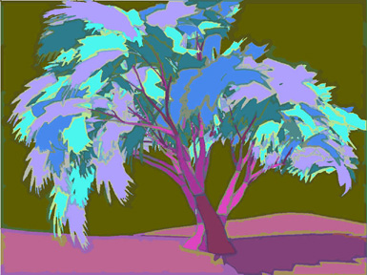
Image 36. Screen Image, 2002.

They usually look best… that certainly suggests an encodable criterion.
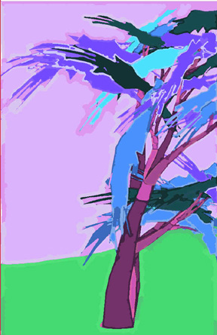
But criteria of this kind generally imply what the program shouldn’t do, not what it should do, and the operative word here is “usually.” If you think of AARON’s output having a bell-curve desirability distribution, the problem is not to guarantee that it all falls in the well-populated middle part. That’s not where the best are. On the contrary, [Image 37 38] the ones I like best are always precisely the ones that fall on the under-populated outer fringes and – this is saying essentially the same thing -- I don’t like any two of them for quite the same reasons. I’m not likely to see many of those, obviously, by giving AARON criteria that imply a single “best” solution.
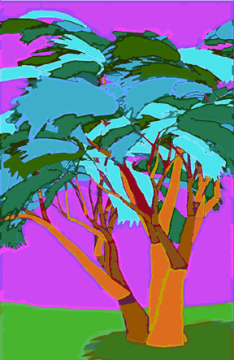
Image 37. Left - “0209-03” Digital Print, 2002. 70” × 45”
Image 38. Right - “0210-01” Digital Print, 2002. 70” × 45”

So there is a meta-criterion for AARON’s performance, which is that a high proportion of its images should be on the outlying fringes of the bell-curve. I’ve been trying to satisfy that criterion all along, of course, as any other artist does. But talking about meta-criteria implies, correctly, that criteria come in hierarchies, not in lists, and they are configured by just the kind of interactions in the individual’s experience – between self, technology and culture, for example -- that I’ve been talking about.

The program’s success in satisfying these criteria is not a measure of its autonomy, consequently, because the criteria derive from my experience, not from AARON’s, and because the strategies I design to satisfy those criteria are simply hard-coded into the way AARON goes about its business.

I used to define autonomy by saying that the program should be able to make paintings in August that it couldn’t have made when I stopped working on it in January, implying that the key was purposeful self-modification. I find myself questioning now whether that was an appropriate definition or whether I wasn’t constructing exactly the same kind of human-referenced wall that kept AARON away from color for so long.

The fact is that I could not have anticipated the images AARON is producing now – images I could not have made myself -- when I started work on trees four weeks ago. I could not have predicted when I finally broke through my brick wall that AARON would become in many ways a better, a more vigorous colorist that I have ever been. I could not have predicted any part of this history when I wrote my first trivial little program thirty years ago. That doesn’t satisfy my definition of program autonomy for the program, certainly, but it does something quite like it for the Harold Cohen/AARON entity.

As regards its place in the future, AARON has now laid claim to two very different positions. On the one hand, in its web-based manifestation, it became the first art-making program in history to provide original art on demand to anyone who wants some. On the other hand, [Image 39] two of its large prints have been hanging since the summer in the San Diego Art Museum; the first time in history that the work of a computer program, untouched by human hand other than the framer’s, could hang in the same context, and on the same terms, as art made by established human artists.

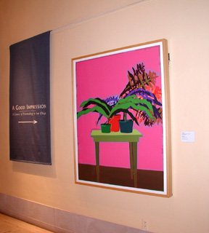
Image 39.

When I stopped by to see the show, I found that the label said that these works were made by Harold Cohen. I told the curator that she didn’t have it quite right and now the label [Image 40] announces that they were made by AARON, a computer program created by Harold Cohen – though the irony of the work being shown by courtesy of the artist seems to have been missed. Whether this must serve as the only reliable signpost to the future, or whether AARON alone can ever be endowed with its own machine-equivalent of the essentially human capacity for self-examination and purposeful self-modification that we now share; I simply do not know. We may have to reconvene on my 135th birthday to find out.
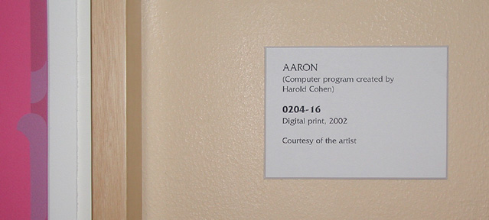
Image 40.

